A+ Computer Science CREATE YOUR OWN WINTER SCENE Lab Value - 100

Lab Goal : This lab was designed to teach you how to design and use of data structures, abstract classes, object instantiation, and graphical animation.

Lab Description : Write a program to create a group of unique snowflake shapes using graphics. Make the snowflakes move down the screen or look like they are falling. When the snowflakes reach the bottom of the screen, they should reappear at the top of the screen and restart the journey down the screen.

Part One :: Use the AbstractShape.java file for the building block of your snowflake and snowman. Extend the AbstractShape class to make FancySnowFlake class and a SnowMan class. Each of the new classes must have a constructor and a draw method in which you will draw the shape. Use WinterScenePanel.java and GraphicsRunner.java to test your classes.

Part Two :: Use WinterScenePanel.java and GraphicsRunner.java to further test your classes. You must get your snowflakes to move down the screen.

Part Three :: Use your creativity to add in at least a Tree and any other objects you think would improve your scene. For each object, you must extend the AbstractShape class.

Part One :
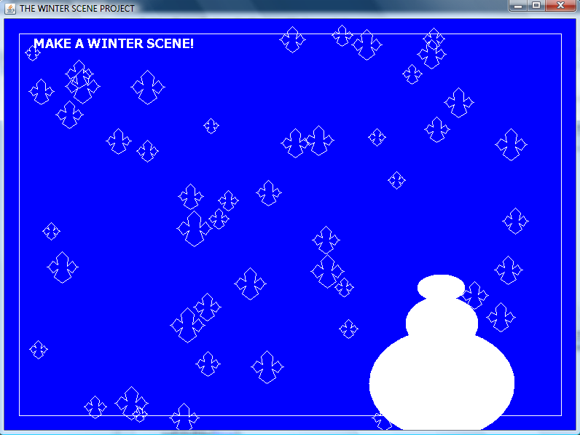
Files Needed ::
AbstractShape.java
WinterScenePanel.java
FancySnowFlake.java
SnowMan.java
GraphicsRunner.java

Design your snowflake any way that you want. The snowflakes are falling down.

